Stable Isotope Analysis Protocol

Detwiler Lab

August 10, 2015
Carmen Tse

General Lab Procedures

During stable isotope analysis be wary of cross contamination with other samples or dirty tools and tables. Before any sample preparation, wipe down the table and tools with 70% ethanol and Kimwipes and put on gloves. If there are any questions, ask your lab supervisor. Always clean up afterwards and place everything back to where they were taken.

Labelling

It is important to label everything to avoid confusion and make it easier to backtrack if needed. Try to label everything twice (ie. Once on the top and once on the sides.) just in case one of the label rubs off. Keep track of samples on either excel data sheet or on paper (ie. State of samples, where they were from, date processed, etc.).

Labelling generally is as follows:

First two letters of genus name, followed by first two letters of species name, then a dash, a number (if it is the first one of this species, put a one, if it is the fourth animal processed of this species, put a four), another dash, and finally the date in the format of month/date/year.

Ex. For the sixth Ondatra zibethicus necropsied on July 5, 2013:

ONDA-6-7/5/13

Discuss any questions on labelling with your supervisor or if you have done it another way so everyone is on the same page.

Collecting, Processing and Storage of Samples

Muscle Tissue

1. Collecting and Storage:

Tools needed:
- Tweezers
- 70% ethanol
- Kimwipes
- Blade/scalpel
- Eppendorfs
- Gloves
- Eppendorf storage Box
- Fine tip sharpie

Animals are usually frozen and then thawed before necropsies. Before or after taking the intestines out of the animal, take a piece of muscle out of a part of the body. Try to be consistent and take the muscle out of a specific area each time a sample is taken (ie. Left leg). Using clean tweezers, place the sample into an eppendorf. Be sure to leave at least 3mm at the top because the muscle will expand in the freezer. Also, try not to leave any airspace at the bottom of the eppendorf because when they are placed in the freeze drier, the vacuum may cause it to come out of the tube. A trick is to cut the muscle into smaller pieces and put them in one at a time than to stick a big piece all at once into the eppendorf. Try to take only lean red muscle with no fat. Close the tube and label the top with the page number of the necropsy sheet in the necropsy binder, species and genus as discussed in the labelling section, and if you are taking multiple samples be sure it is indicated (ie. Labelling one sample A, another B, C, etc.). Place in an eppendorf storage box with a label on the box indicating what will be placed into the box and immediately put it into the freezer at -20˚C. Finally, indicate on the necropsy sheet or an excel data sheet it has been stored in the freezer. Dispose of scalpel/blade into sharps bin and if you are taking another sample from another animal, either wash tweezers with ethanol or grab new ones and wash them with ethanol again. And either change gloves or wash your gloves with ethanol.

2. Freeze Drying:
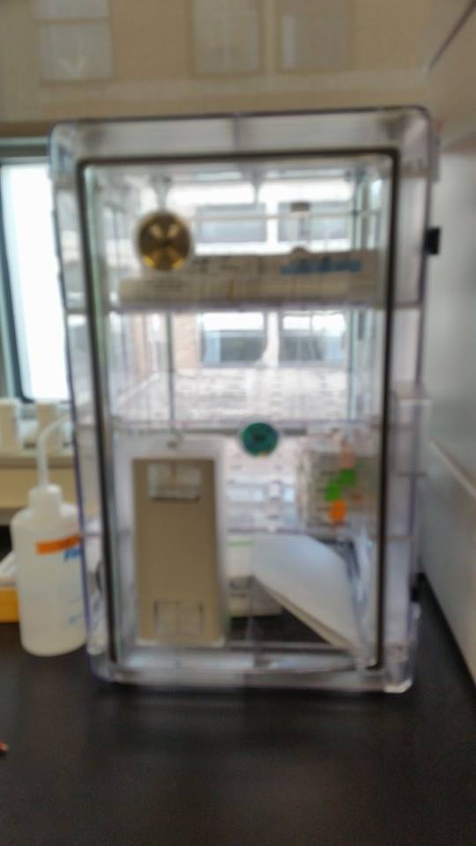
Before starting, make sure the freeze drier is attached to the vacuum and the vacuum is turned on. Prepare your samples by separating each sample in the storage box so they are as far away as possible from each other since they may pop out during freeze drying (ie. In a checker board fashion). If needed, use multiple boxes and stack them in the freeze drier. Take off the lids of the boxes and off of the tubes. Take off the plastic dome of the freeze drier and place your boxes on the four plastic caps. Replace the dome and turn the air valve at the top to 90 degrees to the valve to seal it. Ensure that the plastic cap is inserted into the rubber drain hose. Turn on the freeze drier with the button at the bottom right side of the machine. To begin, press the ‘auto’ button at the front. Dry the samples for at least 48hrs (machine can run overnight and over weekends if needed). Once the samples have been left for at least 48hrs, end the freeze drying cycle by pressing the ‘auto’ button. Turn the air valve very slowly to introduce air back under the dome. Do this step slowly and until you no longer hear the air-rushing in. the samples do not need to be stored in the freezer and the samples are ready to be lipid extracted. If you are not lipid extracting right away put the samples into the desiccator box. Leave the dome off and clean the cooling coils in the freeze drier once the ice on them has melted with paper towels. Do not keep the machine wet. Replace the dome once done.
Figure 1. Desiccator box

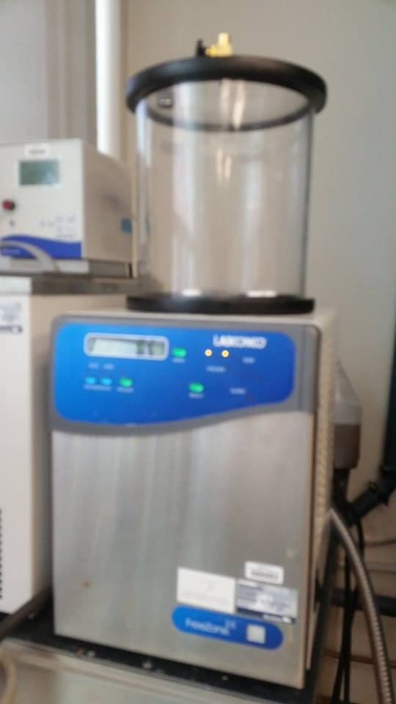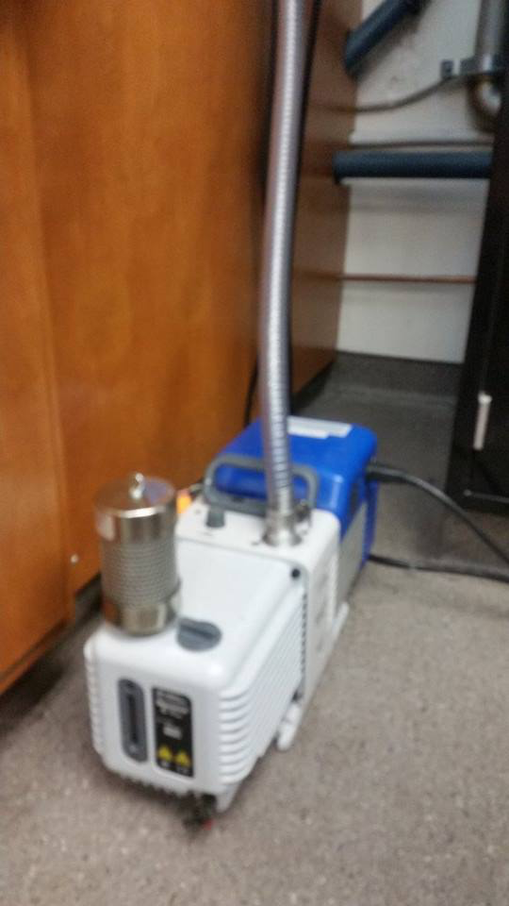
Figure 2. Freeze Drier Figure 3. Vacuum

3. Lipid extraction:

Tools needed:
- Mortar and pestle
- Filter paper
- Kimwipes
- 70% ethanol
- Gloves
- Beaker with thimbles
- Corresponding data sheet
- Petroleum ether
- Scoopula
- Tweezers

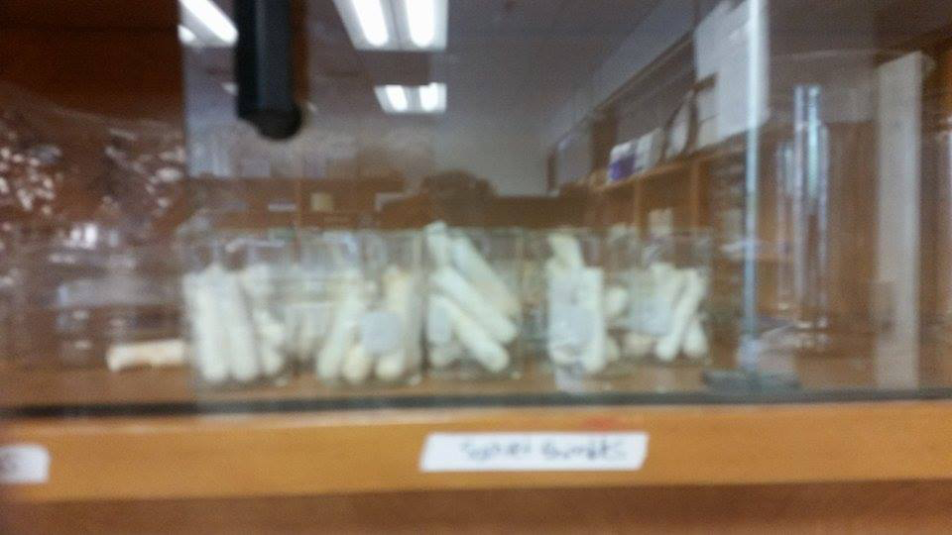
Lipid extraction of any animal tissue will be done in the Soxhlet apparatus. The Soxhlet can run 36 samples at once. Before lipid extracting, the muscle samples must be homogenized first. Clean the mortar and pestle, scoopula and table and make sure they are dry or else the samples will stick to it. Grab as many beakers as needed (each beaker has six thimbles for six samples) and print off the corresponding data sheet off of the computer (ask Dr. Roth if unsure). Take note that each beaker has a number and/or a letter on it, this corresponds to the data sheet printed off. Also, on the data sheet it will say 0 to Big. This corresponds to the notches placed on the thimbles. If there are no notches that corresponds to the data sheet’s zero, if there is a big rectangular notch, that corresponds to the Big. Check the thimbles before you begin to make sure there are no extra pieces of paper or remaining samples from previous trials. Use tweezers to take them out and empty the thimble. Place your first sample into the mortar and crush and mix your sample till it is as powdery as possible. Some animal samples are harder to take apart because of connective tissues and fats, do not worry, the samples will be homogenized again after lipid extraction. Pour your homogenized sample onto a filter paper and wrap it like a burrito and stick the burrito all the way down into a thimble. Wrap it so no samples will fall out. Place the thimble back into the right beaker. Write down your sample ID onto the data sheet. Wash the table, scoopula, mortar and pestle, gloves with ethanol before repeating with the other samples.
Figure 4. Beaker and thimbles
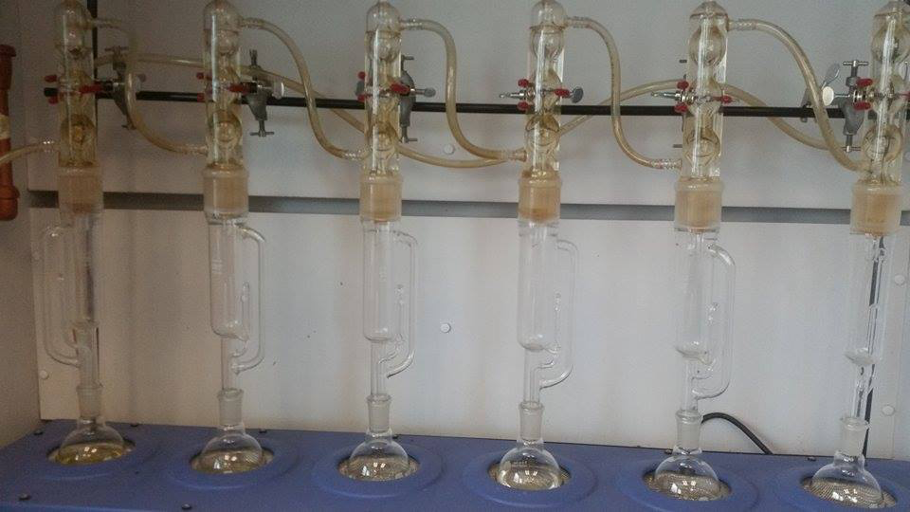
Once all your samples are prepared, prepare the Soxhlet. Unscrew the top section where water runs through and take out the bottom two sections and screw back in the top section. If the petroleum ether is running low or it is getting too yellow, change it. Use the petroleum ether in Dr. Detwiler’s lab in Buller 511. There is a waste bin at BSB 409 (across Dr. Roth’s lab), keys can be found in the key drawer. Try to keep the boiling chips inside the bulb and add more if needed. Make sure the petroleum ether reaches at least the middle to top section of the white hexagon on the bulb. Always pour petroleum ether under the fume hood and wear gloves, as petroleum ether is toxic and highly flammable. If you spill any under the fume hood just close the fume hood and it will evaporate. Using the long tweezers under the fume hood put your thimbles into the middle part of the Sohxlet. Make sure they don’t stack on top of each other and are all at the bottom so the ether can soak it. Put all the pieces back together and make sure the pieces are all snug together to avoid the ether from evaporating. However, do not put them too tightly together as that can make it hard to take apart and the glass can shatter. Put the corresponding thimble in front the Soxhlet. Leave the data sheet under the fume hood.
Figure 3. Soxhlet apparatus
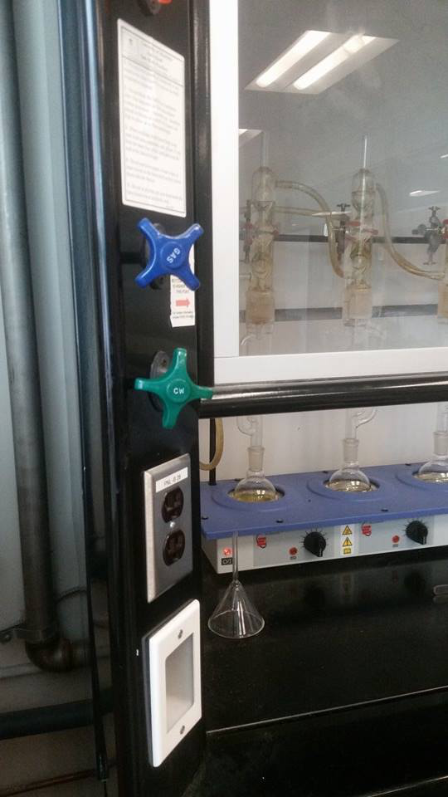
Turn on the cold water and turn it up till it runs smoothly through the top till there are no obvious bubbles. This is to distil the ether. Next, turn on the heaters at the bottom to 4.5, and adjust accordingly after it begins to run to adjust how fast it is boiling. Wait at least one round to make sure the Soxhlet is running properly. Close the fume hood till below the line indicated.
The Soxhlet should run for at least 8 hours but no more than 24 as that risks the Soxhlet running dry. If at any time the fume hood beeps, press the enter button at the top right of the fume hood. This will happen frequently if you are leaving the fume hood above the line.
Figure 4. Green dial is for cold water

4. Unpacking, homogenizing and storage:

Tool needed:
- Tweezers
- Scoopula
- Dental probe
- 70% ethanol
- Gloves
- Kimwipes
- Glass vials
- Sharpie

Once the samples have run for at least 8 hours, turn the water and the heat off. Take out the samples with the long tweezers and put the thimbles into the corresponding beaker. If there is any ether left in the middle section, pour it back into the bulb.
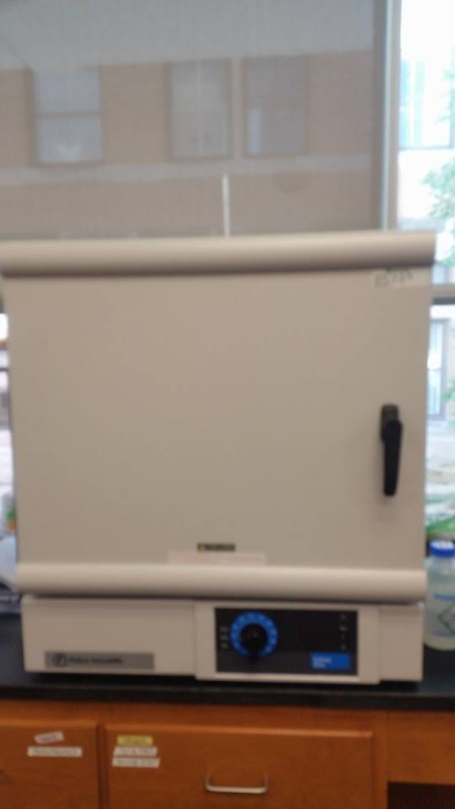
Put the beakers along with the data sheet into the oven at around 60˚C. Look at the thermometer at the top of the oven instead of relying on the dial since the dial runs a little on the low side. Let the ether dry for at least 24 hours. It can run for longer if needed.
Figure 6. Oven
To take out the samples use tweezers to take out the wrapped filter paper samples. Be very careful as the filter paper rips very easily. Once the filter papers are taken out, unravel and using a scoopula, pour the samples into a clean glass vial. Try to avoid getting filter paper into the sample, but the filter paper does not affect the stable isotope reading. Label your vials. Repeat for the next samples, and remember to clean your gloves, tweezers, table and scoopula in between samples.
Samples can now be homogenized again. Using a clean dental probe, homogenize the samples inside of the glass vials. Be careful to not press too hard as that can cause the glass to shatter. Ideally, the samples should have a talcum powder consistency.

5. Weighing:

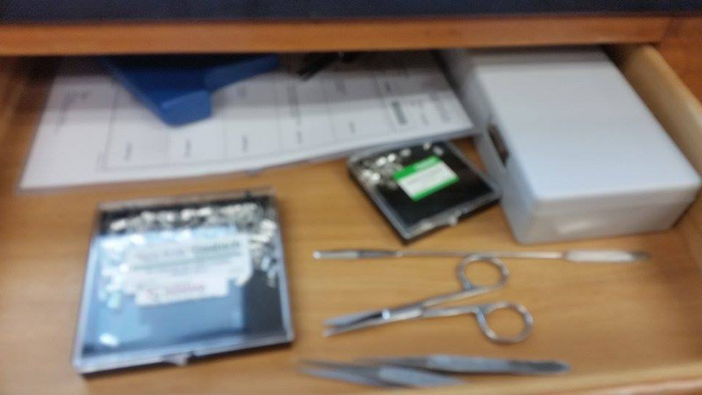
Tools needed:
- Tweezers
- Tin capsules
- Well plates
- Stable isotope GLIER data sheet
- Pencil
- Kimwipes
- 70% ethanol
- Gloves
Figure 6. Tin capsules and tweezers
- Spatula

The microbalance used weighs precise amounts of samples before being sent to the Windsor lab for analysis. It is important here to clean everything well to avoid contamination.
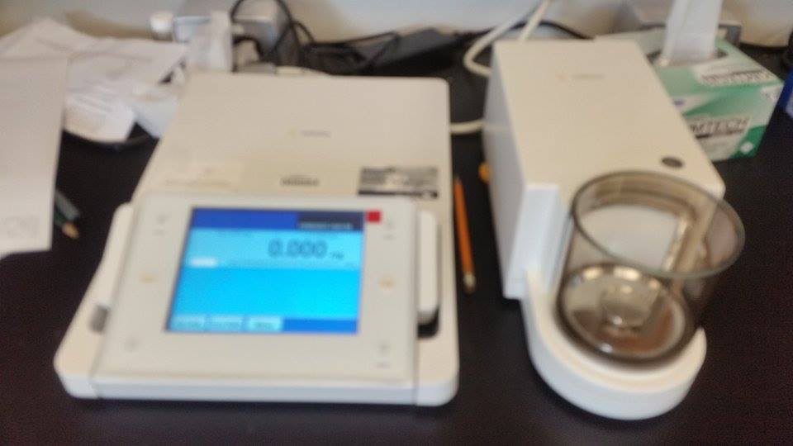
Before starting, take a look at the Stable Isotope Analysis spreadsheet (found on the computer in Dr. Roth’s lab). Notice the letters and numbers correspond to the wells of the well plate. As well, the spaces where it says ‘standard’ are for the GLIER lab to place their standards so do not put anything there. And at certain samples it will require you to make triplicates of a sample (try to use a larger sample if you are working with small samples). Remember to put the correct ID on the sheet and in the right well.
Figure 7. Microbalance
To begin, clean all your tools and the microbalance. Take off the plastic dome and the two metal pieces of the scale inside and wipe it all with ethanol. Place everything back. Turn on the microbalance by pressing the power button. Once it is turned on, the machine usually requires calibration. On the screen the small ‘isocal’ icon will usually be flashing, to calibrate, press this button. It will take a couple minutes to calibrate, do not touch the machine during this time. Once calibrated you can begin weighing your samples. If the ‘isocal’ button flashes anytime during a weighing, finish weighing the sample and then calibrate it again.
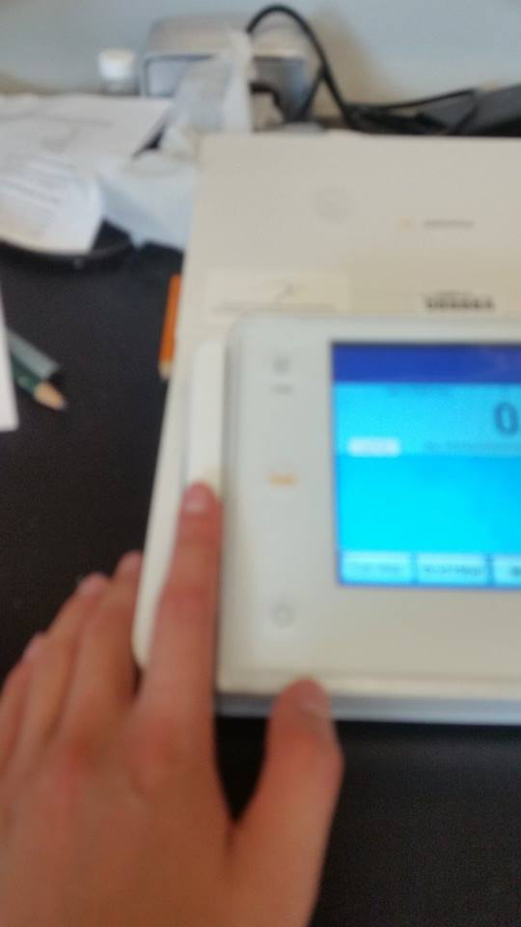
For animal tissue, use the smaller tin capsules, the big tin capsules are for plants. Grab a tin capsule with your tweezers; press the long tab button beside the screen to open the door to the scale. Place the tin capsule onto the scale. Try to place the samples near the middle of the scale since this is where it is most accurate. Close the door by pressing the long tab button again. Wait for the scale to stop fluctuating the weight, and then press the ‘tare’ button on the screen. The screen will now show the weight of the sample and not the weight of the tin capsule with the sample. Always tare every single capsule since all the capsules are a different weight.
Figure 6. Press to open and close door
Take the tin capsule out and by using either tweezers or a spatula, pour a little bit of the sample into the tin capsule. If you spill some, shake off your tweezers on the table and then gently tap the tin capsule to shake the outside samples off. Place the tin capsule back into the scale, close the door, and check the weight. If the weight is in the correct range, take the capsule out and fold it. The correct range for muscle sample is 0.4 to 0.6mg. If you forget the weight, it is posted above the scale on the wall. To fold the capsule, you can use your hands or two tweezers. Make sure it is either folded into a cube or sphere like shape. Also, make sure there are no sharp edges or points sticking out since it may get stuck in the mass spectrometer. Be careful, as the tin capsules tear easily and if they tear, the sample will need to be redone. To check if anything is spilling, toss the capsule gently on the table. If everything is fine, reweigh. Write down this weight on the data sheet along with its ID. You can feel free to write this in ‘mg’ (what is displayed on the scale) instead of ‘ug’ as the paper indicates. Clean all your tools and gloves again with ethanol. You do not need to clean the microbalance again unless you spill sample on it.
If at any time the samples in the well plate gets mixed up, you will have to redo it since there is no way in telling which sample is which.
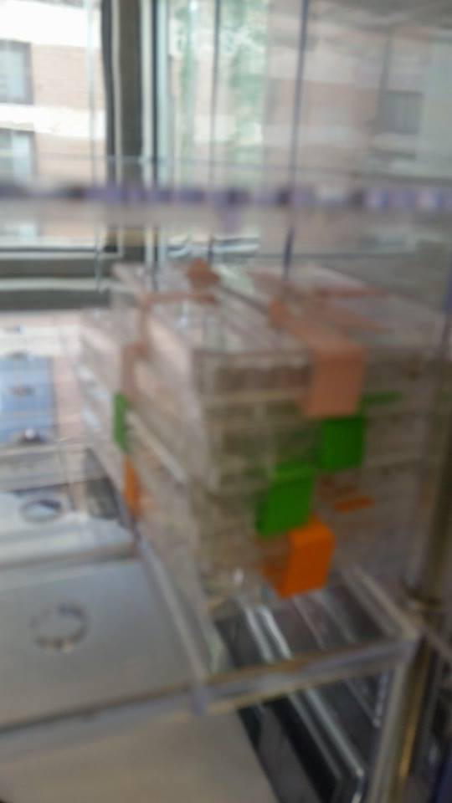
Once the weighing is done, put the lid of the well plate back on and tape it on all four sides and label it. The plate can be placed into the desiccator machine till it is ready to be sent off. Close the door to the microbalance and then turn off the machine.
Figure 9. Tape plates and place in desiccator

Plants

Tools needed:
- Large grocery bags, garbage bags, etc
- A plant press
- Gloves
- Shovel
- Optional: pencil, paper, camera

1. Collecting:
When you are collecting plants out into the field, try to use a shovel to collect roots as well as some plants require the roots for IDing. Grab at least two samples of a plant and take a picture of it. Grabbing more of the same plant is always a good idea. Try to place plants from a similar location into one garbage bag and keep track of which bag came from where. Once back at the lab, if possible, wash at least one plant sample of each species with distilled water till they are clean and there is nothing on the plants and put them in labelled baggies and store in the freezer at -20˚C. Keep at least one plant from each species in bags with some water for moisture into the fridge for pressing the next day. If you are short on time, throw everything into the fridge and wash the next day and place in the freezer as soon as possible.

2. Pressing:
Follow instructions on the pressing guide found in the stable isotope analysis binder or speak with Dr. Ford if you are having difficulties. Make sure to keep track of ID numbers in a notebook or excel data sheet and ensure it corresponds to the write ID number in the press. Once pressed, place in an oven on the fourth floor of Buller (speak with Dr. Ford first). After at least 48hrs, check to see if the plants are dry (check the bulky, large plants). Take them out of the press, store in a box and they are ready to be ID’d.

3. Drying:

Tools needed:
- Gloves
- Sharpie
- 70% ethanol
- Scissors
- Tweezers
- Glass vials

After washing the plants, cut up the plants and take the sections you will be using to do stable isotope analysis on (preferably the sections the animals eats, if unsure, use the whole plant). Keep roots and shoots separate since they show different signals. Take note of which section you used. Place the wash bits into clean petri dishes and label the petri dishes so you can identify them later. Turn on the oven in BSB to around 60˚C. Place the plants into the oven and let it dry for at least 48 hours. After, the plants are dried, take out the plants and put them into glass vials and label them.

4. Ball milling:

Tools needed:
- Scoopula
- 70% ethanol
- Kimwipes
- Gloves
- Tweezers
- Scissors

Ball milling is useful when it is hard to get your samples to a talcum powder consistency and provides for a fast and efficient way to homogenize samples. The ball mill is at the Crop Technology Centre in Dr. Markham’s lab. Before ball milling, use small pairs of scissors to cut up the plants inside the vials as much as possible, this will shorten the time the sample will need in the ball mill.
Turn the ball mill on and set the frequency to 30Hz. Clean all tools, cylinders and the workstation. There are several different sizes of cylinders. For larger samples such as plants the biggest two should be used along with the largest ball bearings. Place your samples inside the cylinders along with the ball bearings. Make sure they are closed. Now, to put the cylinders inside the machine, turn the inner handle (looks like a gear) till it is close to the outer one. And then turn the outside one to accommodate the cylinder. To tighten turn the outside one and then once the outside one is tight, turn the inside handle to brace it. If they are not tightened properly the cylinder will fall out and the machine will stop. Always counterbalance with the same size cylinder even if you are just running one sample. Close the plastic lid to the machine.
Press start to run. The run time depends on the size and type of sample. On average it is two minutes. However, for woodier samples as well as larger ones, it may take three minutes or longer. After the run time, take out the cylinder and check if it is talcum like consistency or your desired consistency. Pour or scoop the sample back into the right glass vial. To help keep track of which vial is which, place the vial on the left if that sample is in the left cylinder and vice versa for the other sample. If you have a small sample, you can scrape some sample off of the ball bearings and the inside of the cylinder. Sometimes the cylinders’ lid may be stuck; you can use the scoopula to pry the lids open, if it is still not coming off, you may need to hit the lid on the table at an angle as if it was a margarita shaker lid that was stuck.
Be sure to clean everything with water or ethanol between samples. Turn off the ball mill and clean your workstation before leaving.

5. Weighing:

Weighing is the same as with muscle sample (above). However, for plants, use the larger tin capsules. Also the weight for plants is 2.5-3.0mg (favouring towards 3.0mg).

